

TOM Integration

Interface Specification
STORELINE
To
ORMS

[D019 to D020]

Project BEN Code: | W60416
Author: | Debasis Pattanaik
Date: | 26/01/2007
Version: | 0.3
Status: | Draft
Modified By:
Reviewed By: | Ganesan, Sankar

Change Record

Author | Date | Version | Change Reference, description
Debasis Pattanaik | 26/01/2007 | 0.1D | Draft
Chakraborty, Supriyo | 29/01/2007 | 0.2D | Draft
Ganesan, Sankar | 30/01/2007 | 0.3D | Draft

Reviewers

Name | Date | Version | Position
Chakraborty, Supriyo | 29/01/2007 | 0.1D | Draft
Ganesan, Sankar | 30/01/2007 | 0.2D | Draft

At least one reviewer is required.

Sign-Off

By signing this form, I understand and agree with the contents of this document.

Business Owner/Customer | Oguz, Erwin
Position | Solution Architect
Signature
Date

Distribution List

Name | Date of Issue | Version
Oguz Erwin
David Onyett
Venkateswara Rao

Document Source

Related Documents: XML files
Directory: <to put>
File Name:
tes.jp.retail.storeline.invadjust.v2.7
tes.jp.retail.retek.invadjust.v2.7
mapto.tes.jp.retail.retek.invadjust.v2.7.4

Information Architecture Context diagram
Will be provided

Mapping spreadsheet
Will be Provided
Table of Contents
1 Introduction 7
1.1 Purpose of Document 7
1.2 Background 7
1.3 Scope 7
2 Description and Requirements for the End-to-End Interface 8
2.1 Description of the End-to-End Interface 8
2.2 Architecture 8
2.3 Requirements for the End-to-End Interface 9
3 Processing required in an Extract-Stage of the interface 10
3.1 Scope 10
3.2 Source Message Schema 10
3.3 Message Format 11
3.4 Message Transport Details 12
3.5 Naming and Configuration 12
3.6 Environment and Security Context 12
3.7 Non-Functional Requirements 13
4 Processing required in the Messaging Stage of the interface 14
4.1 Scope 14
4.2 Data Validation 14
4.3 Filtering 14
4.4 Mapping 14
4.5 Target Message Schema 14
4.6 Message Format 14
4.7 Message Transport Details 15
4.7 Naming and Configuration 16
4.8 Environment and Security Context 16
4.9 Non-Functional Requirements 16
5 Processing required in the <third stage of the interface> 17
5.1 Scope 17
5.2 Data Validation 17
5.3 Filtering 17
5.4 Mapping 17
5.5 Target Message Schema 17
5.6 Message Transport Details 17
5.7 Naming and Configuration 17
5.8 Environment and Security Context 17
5.9 Non-Functional Requirements 17
6 Testing Deliverables 18
7 Deployment 19
8 Assumptions and Outstanding Issues 20
8.1 Assumptions 20
8.2 Outstanding Issues 20
Appendix A Volumes 21
• Glossary 22
Appendix B Document Control 23

Introduction

Purpose of Document
The purpose of this document is to describe the interfacing requirements w.r.t. STORELINE inventory adjustment data (Stock Check adjustments & Wastage adjustments) to ORMS.

The document is of a sufficiently technical in nature to allow a developer to build an actual interface. Additionally the document contains detail that might sit logically within a Technical System Design (TSD) document, but is contained here for expediency. There is therefore no associated TSD for this interface.

This interface is only for US implementations. Turkey implementation does not require this interface.

Background
As part of Tesco Operating Model program, there is requirement to bridge the functionalities of enterprise applications including STORELINE and ORMS. To achieve this functionality, high level process flow architecture has been designed and approved by Tesco’s Enterprise Architecture team. As part of this process flow architecture there is a set of interfaces that has been identified to be developed to transfer Inventory Adjustment data from STORELINE into ORMS.

Scope
The Interface Specification covers:

- audit requirements across the interface
- security requirements across the interface
- timing/frequency requirements or constraints
- support requirements
- archiving
- the data format to be used for the interface at each stage (e.g. xml messages)
- the normal processing required at each stage
- recovery from failure required at each stage
- volumes.

Note that it is Tesco strategy to avoid placing any business logic in integration layer processing.

Description and Requirements for the End-to-End Interface

Description of the End-to-End Interface
The interface is to upload the Inventory Adjustment data (Stock Check adjustments & Wastage adjustments) from STORELINE into ORMS. The Upload is a full upload in nature.

The interface will be governed by BizTalk Orchestration, which expects the Inventory Adjustment data (| delimited flat file) from STORELINE interface. The store line interface will put this file (*.dat) in the shared location through RTI file adapter. The BizTalk server then transfers this file through RTI adopter and process to generate XML file (containing Inventory Adjustment data records). The XML file then put into the ORMS shared location through FTP from which RIB will take into ORMS.

The interface will make use of the audit and traceability components that are being developed as part of the Operational Framework stream. Developers should put a ‘placeholder’ in their code / configurations as appropriate.

Architecture
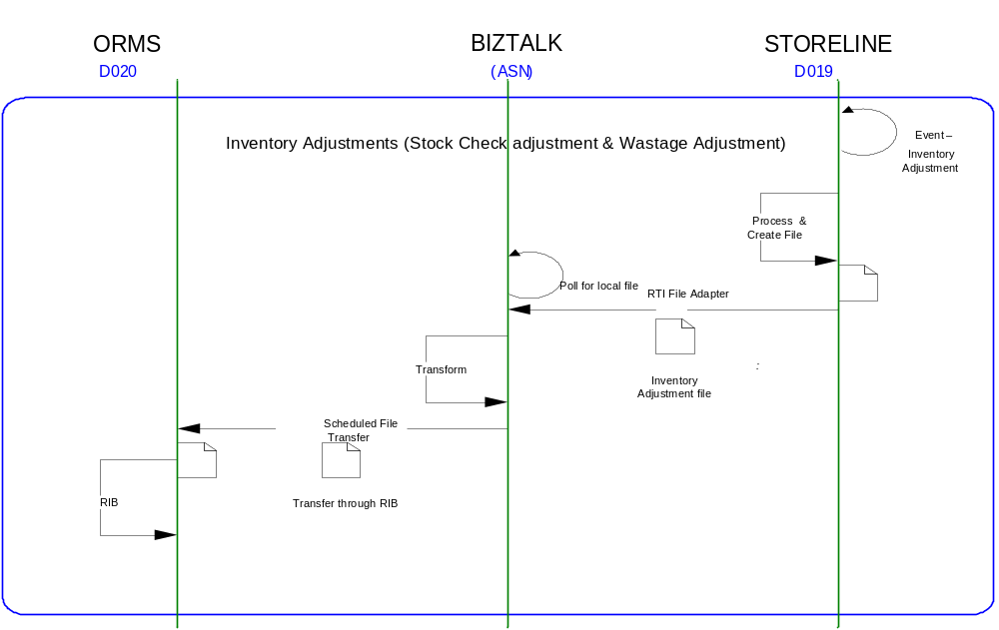

Requirements for the End-to-End Interface

Audit Requirements | The interface will use the components provided by the Operational Framework to satisfy audit requirements.
Security Requirements | The interface executes within a secure private domain. There are no additional security considerations required.
Timing/Cut-off Constraints | To be finalised.
Performance Requirements | The interface should be capable of extracting data in the form of flat file from the shared location at TIMS side and delivering the resulting to another shared location at ORMS side before the identified cut-off time. The interface should run on real time basis.
Reliability and Availability Requirements | The interface-run should be atomic in nature. Where it is not possible to implement an atomic nature of interface, appropriate mechanisms should be in place to raise/alert appropriate parties.
Scalability Requirements | N/A - No scalability issues exist.
Operational Support Requirements | No such requirement has been agreed upon at the time of writing this document. However, it is perceived that there would be interface support requirements after go-live date that would require an evaluation.
Likelihood of Change Requirements | There is no such requirement
Cultural/Global Consideration Requirements | N/A
Legal Requirements | N/A
Compliance To Standards Requirements | No compliance exceptions.

Processing required in an Extract-Stage of the interface

Scope
STORELINE creates a pipe | delimited flat file on real time basis whenever it receives an inventory adjustment (D019) data. BizTalk in turn picks up the file from the same location and produces a positional flat file at another predefined shared location, used by ORMS to pick up the file.

Source Message Schema
Field Name | Optional | Type | Description
HEADER RECORDS
CapturedBy – CreatedBy |  | String
DateOfExtract | Yes | String | Store-line extraction date
DelAfterDate |  | String | Delivery before date
DelBeforeDate |  | String | Delivery after date
Description |  | String | Free form description
DriversName-Courier |  | String | Courier Driver Name
ExpectedDelDate |  | String | Expected Delivery Date
InvoiceNumber |  | String | Invoice Number
InvoiceTaxTotal |  | String | Invoice Tax Total
InvoiceTotal |  | String | Invoice Total
NoOfDetailLines | Yes | Unsigned Int | No. of Detail Items
OrderDate |  | String | Count Order Date
OrderNumber-TransactionNo | Yes | Unsigned Int | Count Order Number
OrderType-CountType |  | Unsigned Int | Count Order Type
OriginalOrderNumber |  | Unsigned Int | Original Order Number
ReasonCode |  | number | Reason Code
RecordType | Yes | String | Record Type
RefNo1 |  | String | Reference No 1
RefNo2 |  | String | Reference No 2
Remarks |  | String | Remarks
ReprocessedFlag |  | number | Re-Processed Flag
StoreAddress |  | String | Location Address
StoreName |  | String | Location Name
StoreNo | Yes | Unsigned Int | Location of extracted data
SupplierAddress |  | String | Supplier Address
SupplierCode-ToStore |  | String | Supplier Code
SupplierName |  | String | Supplier Name
SupplierType |  | Unsigned Int | Supplier Type
TimeOfExtract | Yes | String | Extraction time of data
TotalQty |  | String | Total Quantity
TotalValue |  | String | Total Value
TransactionDateTime |  | String | Transaction Date and Time
UserName |  | String | Operator name
DETAIL RECORDS
DateOfExtract | Yes | String | Storeline extract date
InvoiceCost-Excl-PerUOM |  | String | Invoice cost excluding (Per UOM)
InvoiceQty |  | String | Invoice Quantity
ItemDescription |  | String | Item Description
ItemNumber |  | Unsigned Int | Item CodeItem Code  Used to populate ITEM field
LineNumber |  | Unsigned Int | Transaction line number
Location |  | String | Location in store
OrderNumber-TransactionNumber |  | Unsigned Int | Concatenated with store no to get Batch Number.
OrderQuantity-SentQuantity |  | Unsigned Int
OrderType |  | Unsigned Int
PackSize-Ratio |  | Unsigned Int
ReasonCode |  | Number | Reason Code field direct mapping
RecordType |  | String | Type of record as per Storeline  Used to get Adjusted Qty
ReferenceNo |  | Unsigned Int
SellingPricePerUOM |  | String
Sign |  | String | Sign indicator  - negative  + positive  Used to get Adjusted Qty
StoreNo | Yes | Unsigned Int | Concatenated with Order Number-Transaction Number to get Batch Number.
SupplierItemNo-CatalogueNo |  | String
TaxPercentageOnCost |  | String
TimeOfExtract | Yes | String
TransactionQty |  | String | Transaction Quantity concatenated with sign indicator will give meaningful value.  Used to get Adjusted Qty
TrsCostPrice-Excl-PerUOM |  | String
UOMCode |  | Unsigned Int
UOMDescription |  | String

Message Format
The source message is in the form of pipe | delimited file from STORELINE is getting converted into the target file format in a package.

Message Transport Details

Feature | Specification | Additional Information
Source System Name | STORELINE
Source Platform / OS | IBM AIX
Source Physical Location
Source Underlying Data Storage Technology | SQL Server
Target System Name | Biztalk 2006
Target Platform / OS | Biztalk 2006 Server
Target Physical Location
Target Underlying Data Storage Technology | File Share
Transfer Function | HTTP (Put/Post) □  HTTPS (Put/Post) □  Message Queue □  FTP ☑  File Drop(Windows) ☑  (XCOM) □
Data Format. | XML □  Delimited ☑  Positional □ | | delimited
Decryption/Encryption | No
Decompression/Compression | No
Transmission Mode | Synchronous □  Asynchronous ☑  Bulk Data □
Real-time/Scheduled Batch | Not yet decided
Archiving | There is no requirement to archive the messages.
Logging | Logging should occur, such that the message can be recreated if necessary.
Error Handling | Not yet decided  Processing should prevent sending of duplicate messages, unless this occurs during recovery from failure.

Naming and Configuration

Biztalk – 2006
Package Name: Tesco_ TOM_Integration_INVENTORY_ADJ_from_STORELINE_to_ORMS
BizTalk Procedure
Name | Tesco_TOM_Integration_INV_ADJ_ORMS
<Placeholder for other package components/steps>
<Placeholder for other package components/steps>

Environment and Security Context
Account details will be included here once we have visibility of the environments.

Non-Functional Requirements
Not Applicable

Processing required in the Messaging Stage of the interface

Scope
BizTalk monitors the file in the configured location for every new file and submits the same to the remote UNIX share via FTP. The resultant file is a XML file.

Data Validation
Data Validation will be done by the target ORMS system.

Filtering
There is no filtering requirement.

Mapping
Mapping document will be provided subsequently.

Target Message Schema
Target Message Schema in XSD format:

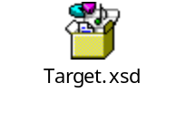

The Description of the fields as mentioned in the XSD file:

Record  Name | Field Name | Field Type | Start Pos | End Pos | Description
FHEAD | CreateDate | string | 36 | 43 | Storeline extraction data date - DateofExtract
FHEAD | CreateTime | string | 44 | 49 | Storeline extraction data time – TimeofExtract
FHEAD | FileLineNumber | ui8 | 6 | 15 | Constant value - ‘1’ (one-numeric).
FHEAD | FileTypeDefinition | string | 16 | 35 | Constant value - TSCINVADJUPLD_v1.6
FHEAD | Location | ui8 | 51 | 60 | Source schema field - Store No
FHEAD | LocationType | string | 50 | 50 | Constant value – ‘S’
FDETL | AdjQty | ui8 | 55 | 67 | Calculated field (RecordType, TransactionQty & Sign.)
FDETL | BatchNumber | string | 16 | 29 | Concatenated field ("00000000",OrderNumber-TransactionNumber & Store No.)
FDETL | DateTime | string | 72 | 85 | Concatenated field - DateofExtract & TimeofExtract.
FDETL | FileLineNumber | ui8 | 6 | 15 | Positional record number
FDETL | Item | string | 30 | 54 | Source schema field - ItemNumber
FDETL | ReasonCode | string | 68 | 71 | Compared both (SetHdr & SetDtl) ReasonCode and pass the non-empty field.
FTAIL | FileRecordNumber | ui8 | 6 | 15 | Total record including FHEAD & FTAIL.
FTAIL | NumberofFileDetailLines | ui8 | 16 | 25 | Total no of detail record

Message Format
The source message is a pipe | delimited flat file from STORELINE and is getting converted into the target file format for ORMS in a package. The target message is a XML file.

4.7 Message Transport Details
For messages destined for ORMS system, the following applies.

Feature | Specification | Additional Information
Source System Name | Biztalk 2006
Source Platform / OS | Biztalk 2006 Server
Source Physical Location
Source Underlying Data Storage Technology | File System
Target System Name | ORMS
Target Platform / OS | IBM AIX
Target Physical Location
Target Underlying Data Storage Technology | RDBMS
Transfer Function | HTTP (Put/Post □  HTTPS (Put/Post) □  Message Queue □  FTP ☑  File Drop (Windows) □  (XCOM) □  RTI File Adapter □
Data Format | XML ☑  Delimited □  Positional □
Decryption/Encryption | No
Decompression/Compression | No
Transmission Mode | Synchronous □  Asynchronous ☑  Bulk Data □
Real-time/Scheduled Batch | Real-time
Archiving | There is no archiving requirement
Logging  Should logs be kept of all actions? For how long should these be stored? | Logging should occur, such that the message can be recreated if necessary.
Error Handling | Not yet decided  Processing should prevent sending of duplicate messages, unless this occurs during recovery from failure.

Naming and Configuration

Biztalk 2006
Instruction Name:
Instruction Details
Description | To be determined
Enabled | True
Type
Operational Window
Schedule | N/A
Enabled | False
Host Details
Account | To be determined
Operational Details
Worker Threads
Priority
Batch Size
Period
Retry Attempts
Timeout
Require Data Send
Exception Management
Treat Fatal Adapter Exception As
Treat Unhandled Exceptions As

Environment and Security Context
Account details will be included here once we have visibility of the environments.

Non-Functional Requirements
On successful delivery of the file to the target system, the audit log should be updated via the Operational Framework pipeline component or adapter (to be determined).

In the event of a failure the file should be written to the failed files location, and an alert should be raised.

Processing required in the <third stage of the interface>

Scope
There is no intermediate staging is required for this interface. So this section is not applicable.

Data Validation
Not Required

Filtering
Not Required

Mapping
Not Required

Target Message Schema
Not Required

Message Transport Details
Not Required

Naming and Configuration
Not Required

Environment and Security Context
Not Required

Non-Functional Requirements

Not Required

Testing Deliverables
Unit Test Scripts and test cases are kept at the following location <location>

Deployment

Assumptions and Outstanding Issues

Assumptions
ID | Assumption

Outstanding Issues
ID | Issue | To be addressed by
1 | File naming format to be confirmed | Erwin Oguz
2 | Server Physical Location of the server and file | Erwin Oguz
3 | Error handling | Erwin Oguz
4 | URL in XSD needs to be defined | Erwin Oguz
5 | Failure Folder Location to be defined | Erwin Oguz

- Volumes
- Glossary

Acronym | Term | Description
EAI | Enterprise Application Integration | The process of meeting the data requirements of applications by providing a message based transport from disparate data sources across all forms of enterprise technology.
EAI Layer | Enterprise Application Integration Layer | Refers to the integration services provided to implement EAI. In contrast to the EIA Layer for data services. See below.
EIA | Enterprise Information Architecture | Creation of a strategic single view of data across the enterprise.
Interface | Interface | Many definitions exist for 'interface'. In general, 'interface' refers to the link between a data source and a data target. And there are properties of the interface in this context. However more specifically 'interface' refers to one end of a data link, hence the terms source interface and target interface, and both the source interface and the target interface will have specific properties of their own.
ORMS | Oracle Retek Merchandising System | Retek Merchandising System is getting installed for TESCO Merchandising operations in US. This system will governs the Merchandising operations; Receive base Master & Transaction data and from other systems and Provide data to next level of operation system as part of Retail systems chain.
RIB | Retek Integration Bus | This is an integration Interface between the Oracle Retek modules.
Storeline | STORE used for inventory purposes. | The store line operates on Tesco deals with the inventory control.
XSD | XML Schema Definition | It describe the elements in an Extensible Markup Language (XML) document
XML | Extensible Markup Language | An open standard for describing data. It is used for defining a common method for identifying data. It supports business-to-business transactions and also uses electronic data interchange and Web services.
FTP | File Transfer Protocol | The Internet File Transfer Protocol (FTP) is defined facilities for transferring files to and from remote computer systems.
FHEAD | File Header Record | This is File header record identifier. This string will get inserted at the beginning of the file.
FTAIL | File Tail Record | This is File tail record identifier.
FDETL | File Detail Record | This is File Detail record identifier.

- Document Control
Change Record

Author | Date | Version | Change Reference, description
Debasis Pattanaik | 26-Jan-2007 | 0.1D | Draft
Chakraborty, Supriyo | 29/01/2007 | 0.2D | Draft
Ganesan, Sankar | 30/01/2007 | 0.3D | Draft

Related Documents

Author | Date | Version | Title
To be filled

Distribution

Name | Position | Approver/Contributor/Other
Erwin Oguz | Enterprise Architect

